Keypad
3110-016

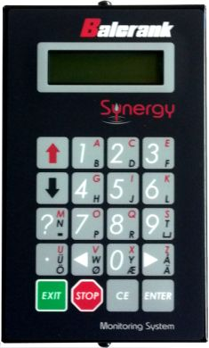

Table of Contents
1. Introduction 3
2. Mechanical installation 3
3. Electric installation 3
4. Configuration 4
4.1. Check before configuration 5
4.2. Addressing the new module 5
4.3. SET-UP mode 5
4.4. Change address [KP//Address] 5
4.5. Recommendation for setting addresses 6
4.6. Change Sphere number [KP//Snr:] 6
4.7. Set-up for reader input, [KP//Baud:]. 6
5. Using a KeyPad module 7
6. Set time and date. 7
6.1. Set date [CLOCK/Date] and [CLOCK/Time]. 7
7. Installing a serial port kit (833022) 8
8. Fast Menu Codes 9
9. Technical specification 10

Introduction
The Keypad is used to configure a Synergy monitoring system, as well as initiate dispenses, stop dispenses and check previous dispenses.
NOTE! The Synergy installation guide (SB3080) should be available when installing and configuring a Keypad.

Mechanical installation
The Keypad is mounted in a visible location within comfortable reach of the user using the two 5mm holes in the bottom/back of the enclosure.
It is possible to mount the lid with the keys and display in two ways, with the display window either in the deep end or the shallow end. There are two 16mm “Knock-Out” cable inlets in both of the short sides of the box. Other cable inlets can be drilled in either the short sides or in the bottom of the box.
NOTE! When the display window is placed towards the deep side of the box it is possible to let a cable in at both of the short sides of the box.
NOTE! When the display window is placed towards the shallow side of the box it is only possible to let a cable in at the deep side of the box.
NOTE! With the 1 card model the display window can be placed booth ways and it is still possible to let cables in at both the top and the bottom.

Electrical installation
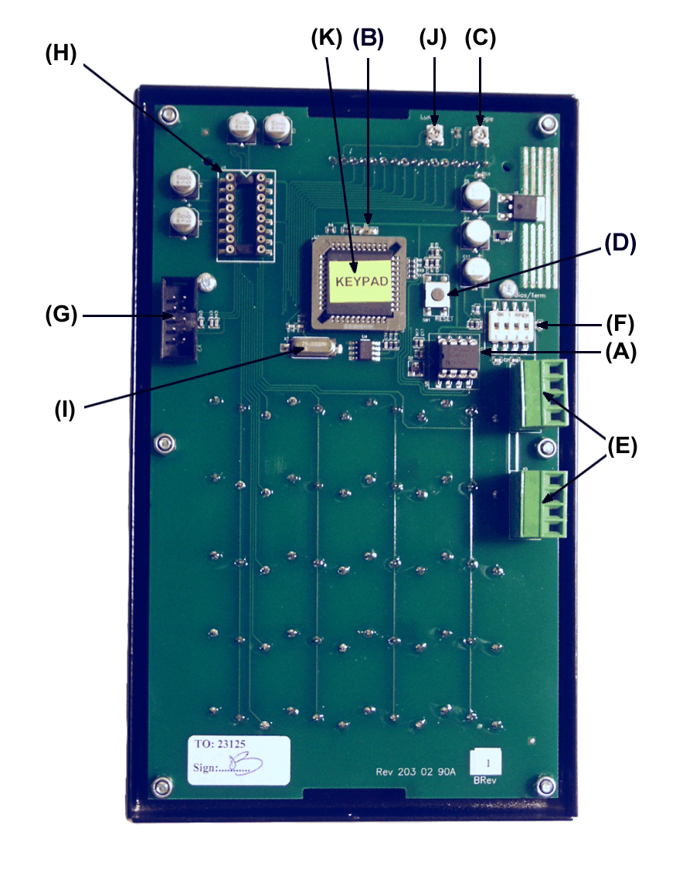
The module has a number of connectors, sockets and controls. Where they are depends on if it is a 2 card keypad or a 1 card keypad.
- Shows the replaceable communication driver.
- If this LED flashes it indicates that the Keypad is working properly. If the LED is unlit or constantly lit something is wrong.
- The angle of sight (contrast) can be adjusted with this trim screw.
- Shows the location of the RESET-button.
- Points out the location of the two 4-pole communication connectors, each marked with A, B, +24 V and Gnd. Connect these to the communication loop in the existing system. Follow the cable recommendations in the Synergy Installation Guide (SB3080). The module gets its power supply through the communication cable.
- DIL switches for termination and BIAS are found here.
- Shows the connector for the optional serial port.
- Shows the socket for the optional serial port driver.
- Processor crystal, 4MHz standard for 2 card model and 25 MHz standard for 1 card model.
- Back light intensity, only on 1 card model
- Microcontroller chip, white label OTP or yellow label FLASH. The 1 card model must have FLASH chip but the 2 card model can use booth OTP and FLASH.
The 2 card keypad is pictured on the next page.

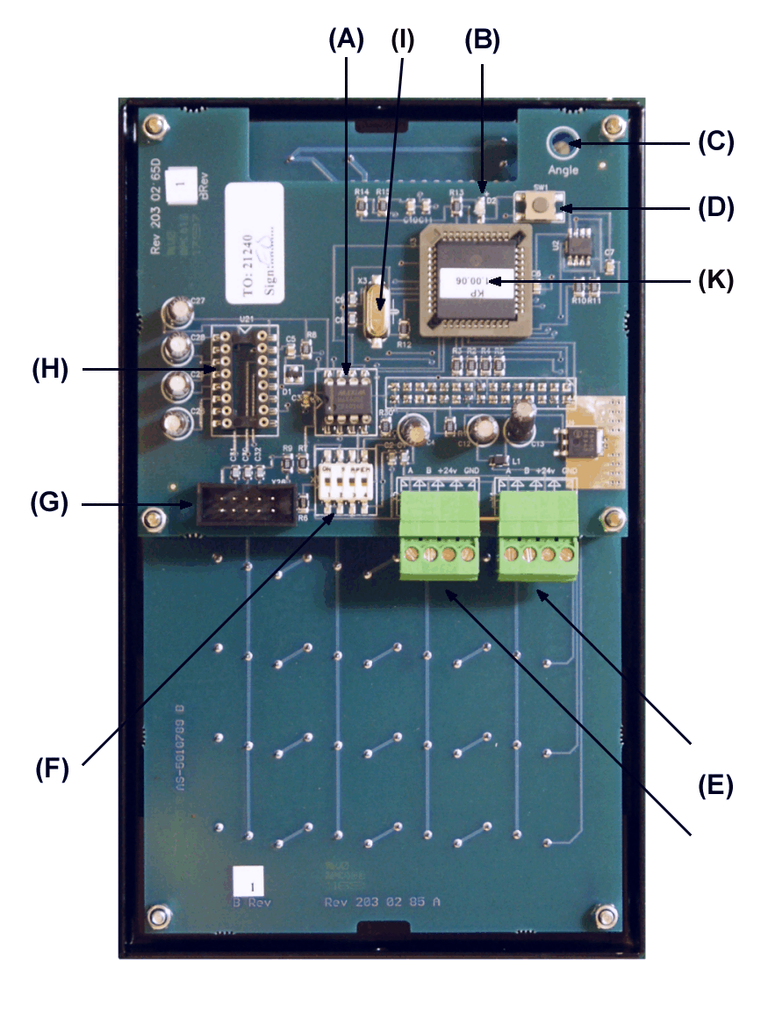

Configuration
A Synergy configuration sheet should always be filled out or updated during the installation and configuration.
NOTE! To obtain technical support a copy of the configuration sheet for the complete installation must be sent to Balcrank Technical Services:
techservice@balcrank.com
fax: 1-800-763-0840 Attention: Tech Services

Check before configuration
Check that the module is working and communicating with the system according to the Synergy Installation Guide (SB3080) chapter Testing modules.
NOTE! Do not forget to check and adjust the termination and BIAS (DIL switches) according to the Synergy Installation Guide (SB3080).

Addressing the new module
A new module has a default address on delivery. To address a new module or one with an default or unknown address you press and hold the RESET-button for 5 seconds. This will give the module a temporary address (DFF0). Next, enter SET-UP mode on a Keypad and press 0 + ENTER to access the Main menu of the module. Find the menu to change module-address (see below).
NOTE! You can only install one module at a time using this method. If you hold the RESET-button on multiple units simultaneously only the most recently activated is active.
TIP! Follow section 4.5, “Recommendation for setting addresses” when setting addresses.

SET-UP mode
Type the word ”SETUP” on a Keypad and press ENTER.
Reel:SETUP ‡
EXIT STOP CE ENT

PASS:_ ‡
Enter password

Addr:3???_ ‡
Address[code]

KP: ‡
KP Main menu

Type the password and press ENTER.

Type the address of the module you want to configure and press ENTER to access its main menu.
You can add the 4-digit fast menu code (see section 8) to go directly to the desired menu.
Scroll through the module sub menus by pressing ↑ or ↓. When the desired menu is shown press ENTER and so on.

Change address [KP//Address]
Enter the [KP//Adress] by pressing ENTER
KP: ‡
KP Main menu

Address:3XXX ‡
Set Address 3???

Address:3XXX ‡
Set Address 3???

Address:3XXX ‡
Set Address 3???

Press ENTER to show the cursor.

Type the desired address confirm with ENTER.
When the cursor vanishes you are finished.
Press EXIT twice to exit set-up.
NOTE! If two or more modules get the same address the system will not work. In that case you have to change address again.
TIP! Follow section 4.5 “Recommendation for setting addresses” when setting addresses.

Recommendation for setting addresses
Each module demands a unique 16 bit hexadecimal address. There are some forbidden and some reserved addresses but it is possible to use all addresses between 0001 and 9999. To make it easier to support the system we recommend you follow the table to the right.
Address Module
0000 – 0xxx Forbidden
1000 – 1xxx MPDM
2000 – 2998 PM with database
2999 PC database (reserved)
3000 – 3xxx KeyPad
4000 – 4xxx LED-display
5000 – 5xxx Reserved
6000 – 6xxx Reserved
7000 – 7xxx Reserved
8000 – 8xxx TCM
9000 – 9xxx Other
A000 – FFFF Forbidden
This means for example that the first KP should have the address 3001 and the next one 3002. It is a good idea not to use the default address 3000, it makes it easier to add new KP’s.
NOTE! Do not forget to write all used addresses in the Configuration sheet to avoid collisions/duplications.
NOTE! Address 0000 is forbidden and addresses larger than 9999 are reserved for the system.

Change Sphere number [KP//Snr:]
Spheres can be used to connect a keypad exclusively to a certain workplace or department. This function is disabled if an OTP chip is used (White label) and enabled if a flash chip is used (Yellow label). See section 3 “Electrical installation”.
KP: ‡
KP MainMenu

Address:3XXX ‡
Set Address 3???

Snr:XXX ‡
Set Sphere 0-255

Snr:XXX ‡
Set Sphere 0-255

Enter menu [KP//Address] by pressing ENTER.
Scroll to menu Snr: by pressing ↑ or ↓.
Press ENTER to get the cursor.
Type in the desired sphere and acknowledge by pressing ENTER. When the cursor disappears, it is finished.
Press EXIT twice to leave Set-Up mode.

Set-up for reader input, [KP//Baud:].
The keypad is prepared for handling values input by some kind of reader. To be able to connect a reader to the keypad a serial port kit (part number 833022) has to be installed.
KP: ‡
KP MainMenu

Address:3XXX ‡
Set Address 3???

Snr:XXX ‡
Set Sphere 0-255

Baud:XXX ‡
Set baud rate !

Baud:2400_ ‡
Set baud rate !

The keypad software will auto detect the presence of this kit (the serial driver chip).
The kit can be seen in section 9 “Technical specification”.
A keypad with an installed serial port kit, see section 7 “Installing a serial port kit”, has advanced functions for handling different types of RS-232 serial readers such as barcode, magnetic card, smart card, etc readers.
It uses 8 data bits, no parity and 1 stop bit asynchronous or synchronous communication.
The baud rate can be set to different speeds depending on the keypad model and chip.
All models and chip types can be set to 1200 or 2400 baud.
For a single board keypad 1200, 2400, 4800, 9600, 14400 and 19200 can be used. Advanced input filtering can be used to extract only needed values. A two board keypad can also use these speeds if the crystal is changed to 25MHz.
If an invalid baud rate is set the 1200 baud rate will be saved.
Readers can be used in a system without a PC but on older systems the baud rate and the functionality can only be set by using a PC with Synergy WinTools professional installed.
For newer systems or recently updated systems it is possible to set the baud rate from a keypad but to set other functionalities, a PC with Synergy WinTools professional is required.
All settings are saved in a flash memory and remains if the power is disconnected.

The set baud rate function from a keypad only exists if a flash chip is used (Yellow label), see section 3 “Electric installations”, and the chip software version is KP10010RC2 or later.
Enter menu [KP//Address] by pressing ENTER.
Scroll to menu Baud: by pressing ↑ or ↓.
Press ENTER to get the cursor.
Type in the desired Baud rate and acknowledge by pressing ENTER. When the cursor disappears it is finished.
Press EXIT twice to leave Set-Up mode.

Using a Keypad module
The keyboard of the Keypad is equipped with multifunctional buttons. The figures 0-9, left and right arrow, STOP, EXIT, CE, ENTER and (.) is accessed directly. They have white text.
The Alphabet is accessed by first pressing red ↑, black ↓ or two times black ↓.
Do not press and hold the arrow button.
The red letters are typed by using first the red ↑ and then the button with the letter.
The black letters are accessed by first pressing the black ↓ and then the button with the letter. On buttons with two black letters, [Ö Ø Æ Å], pressing first black ↓ twice and then the button with the letter will let you access the lower letter. The active letter is shown in the upper right corner of the display.
On some models of keypads the “space” and “-“ is missing on the layout. You can access them as follows.
To enter a “space” press black ↓ twice and then “9”.
To enter a “-“ sign press black ↓ twice and then ”?”.
NOTE! Letters can be used for PIN codes, JOB numbers, names and passwords.
EXIT is used to leave without doing more changes. By typing an identification string and then the STOP button you cancel the current process. CE button erases a typed value. ENTER acknowledges that something should be done.

Set time and date.
If the system is equipped with a real-time clock module (CM) this can be configured using a Keypad

Set date [CLOCK/Date] and [CLOCK/Time].
Type the word “CLOCK” on the Keypad and press ENTER.
Reel:CLOCK_ ‡
EXIT STOP CE ENT

Date:01.11.28 ‡
FORMAT YY.MM.DD

Date:01.11.28 ‡
FORMAT YY.MM.DD

Time:09.30.25 ‡
FORMAT HH.MM.SS

Time:09.30.25 ‡
FORMAT HH.MM.SS

Current system date is shown. Press ENTER to set date or ↓ and ENTER to set time.
When the cursor is displayed, type the correct date or time and press ENTER.

When the cursor disappears the new setting is applied.
NOTE! Do not forget the dot between HH.MM.SS/YY.MM.DD!

Press EXIT twice to exit configuration.

NOTE! It may take up to five minutes before all modules are updated.

Installing a serial port kit (833022)
The serial port kit can be seen in section 9 “Technical specification”.
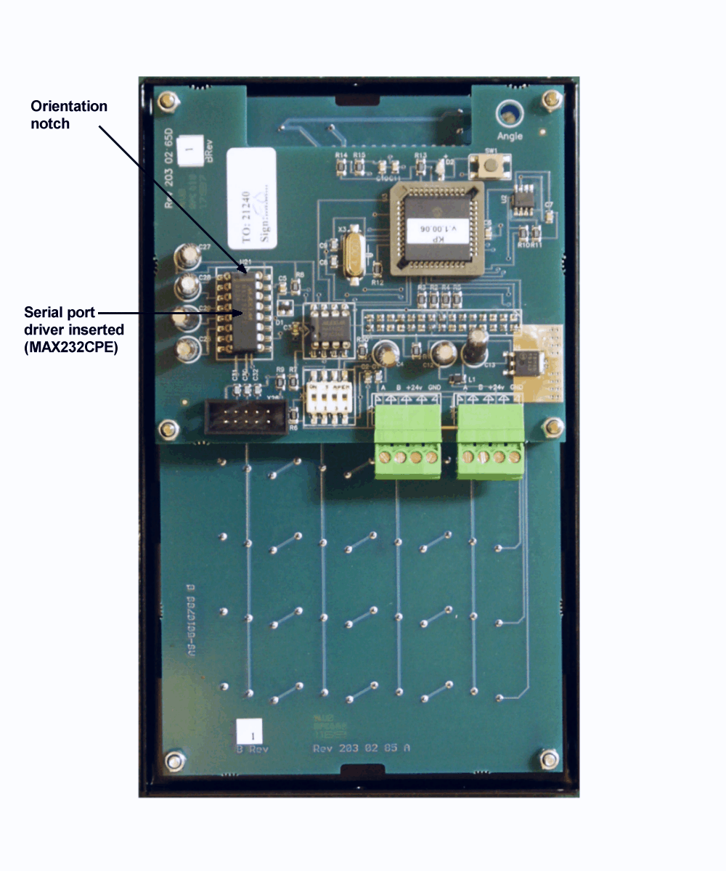
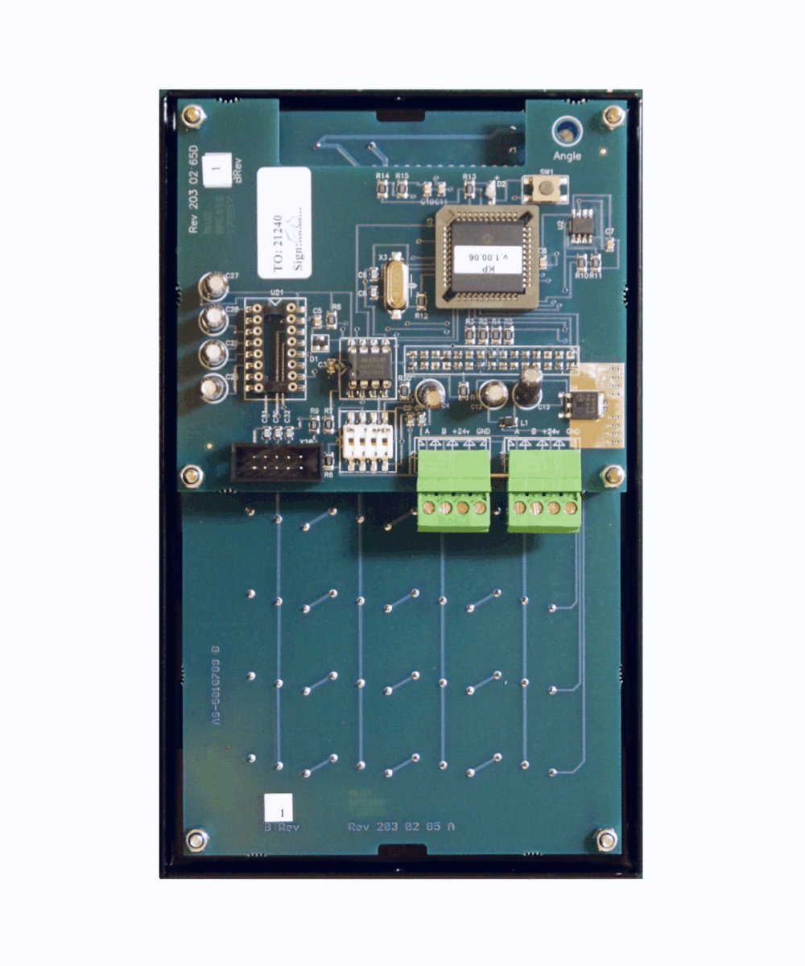
Open the keypad and insert the RS-232 serial driver in its socket (H). Make sure that all legs are properly inserted and that the driver chip is oriented the correct way.
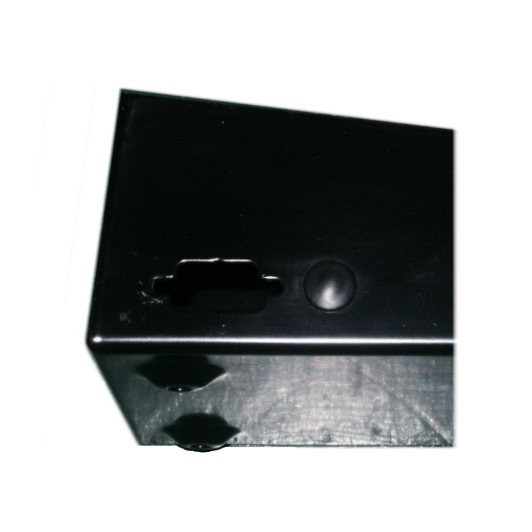
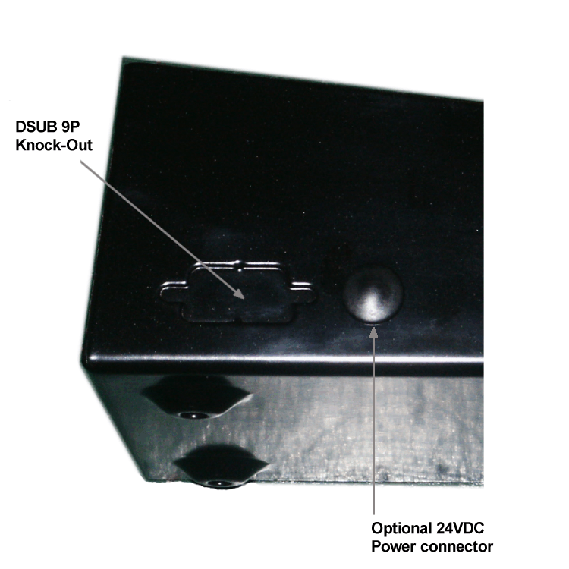
Remove the DSUB 9-pole knockout.
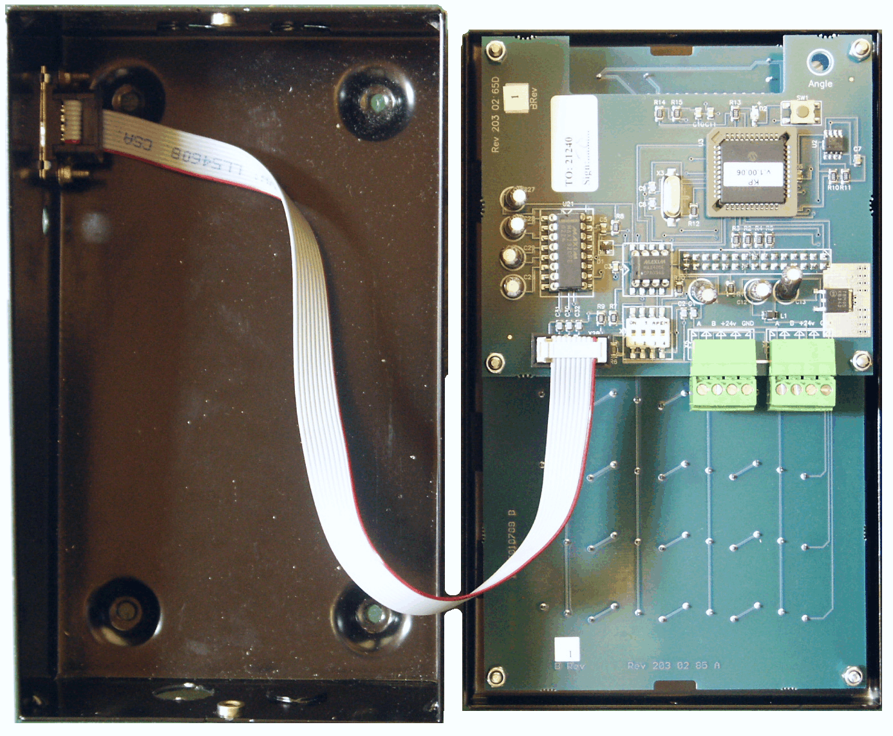
Mount the 9-pole DSUB connector of the serial port cable in the hole and attach the 10-pole DIL-connector on the keypad PCB.
After the hardware installation the keypad has to be set to handle the serial port properly. This can only be done from a PC running Synergy WinTools professional. After the setup is done there is no need for a PC to use the serial port.

Fast Menu Codes
With a PC, the Synergy WinTools software and a SIO the quick menu that appear when you press “?” can be adjusted. Typing a menu name, the module address and then a code can do this. Password can be used if desired.
This code can also be entered together with the address after you have typed SETUP followed by the password.
For a KeyPad it will look like this:
Change address 30000800 YYYYY where YYYYY=password
Part | Function | Address | Code | Comment
Main menu | Change address |  | 0800
 | Change Sphere |  | 0801
 | Change Baud rate |  | 0803

Technical specification
Printed circuit board
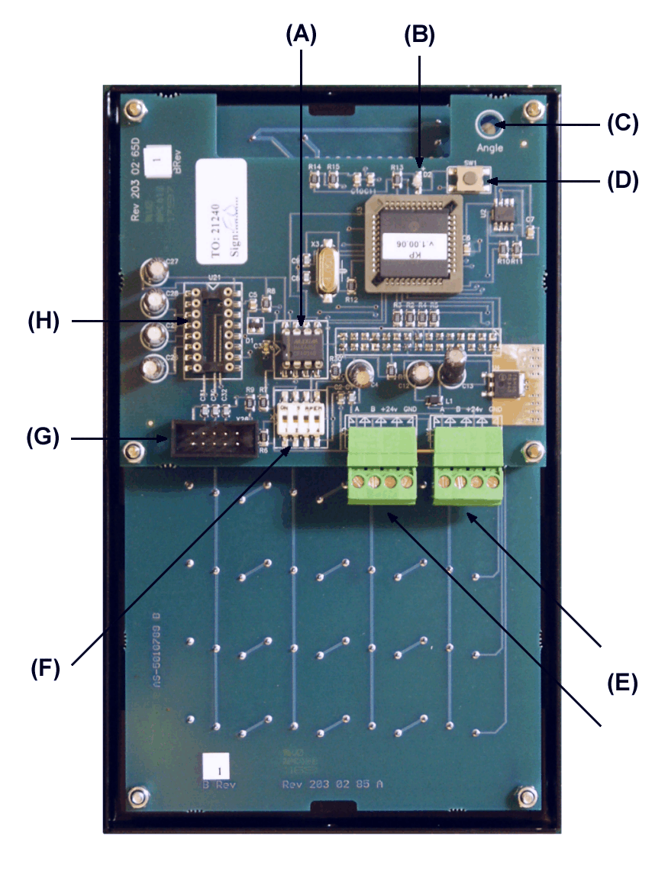
Net ports: 2 pieces of Synergy ports (E) for data-communication.
Connector: 1 piece of serial port connector (G).
Socket: 1 piece of 16-pin DIL-socket (H) for a MAX232CPE serial port driver.
LCD display: 2x16 signs with backlight.
Sight angle adjust (C).
Keyboard: 20 buttons covered with polycarbonate plastic overlay.
Other: RISC-based microprocessor
EEPROM, 64KB.
Reset button (D).
Termination DIL-Switches (F).
Power supply: 24 VDC through communication cable.
Max current: 100 mA
Casing
Power supply: 24VDC, 100mA.
Casing: Strong black powder painted steel box.
Outer measures: 113 x 188 x 62 mm.
Mounting: 4 x ø5 mm
CC = 68 X 140 mm
Weight: 1,2 kg
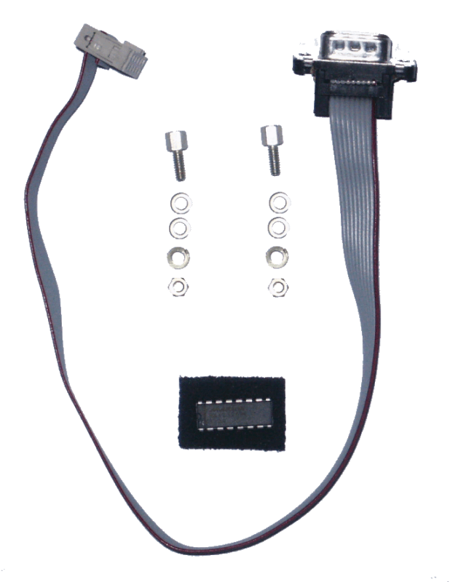
Optional: Serial port kit part number 833022.
The kit contains:
One 10-pole female to a standard DSUB 9-pin male connector.
One MAX232CPE RS-232 serial port driver.
Two sets of chassis connector screw with washers and nut.
Environment
Use: Indoors.
Temperature 0 - +55°C
Humidity 90-95%, not condensing
Transport: Temperature –40 - +70°C
Humidity 90-95%, not condensing
Storage: Temperature –40 - +70°C
Humidity 90-95%, not condensing

